Electromagnetic Field and Power Distribution Analysis of a Circular Resonator in CST Studio Suite.
Test Case 1:
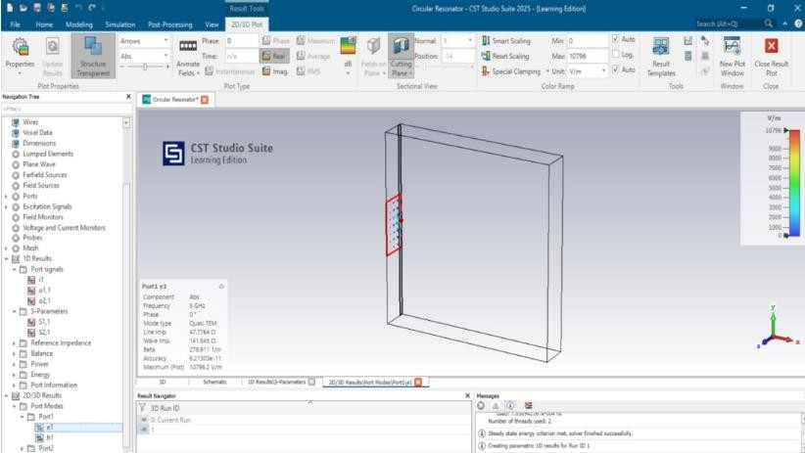
Analyse the electric field and magnetic field distribution at Port 1of the circular resonator and examine the electric and magnetic field parameters at Port 1 for studying electromagnetic field behaviour and validating the system performance.
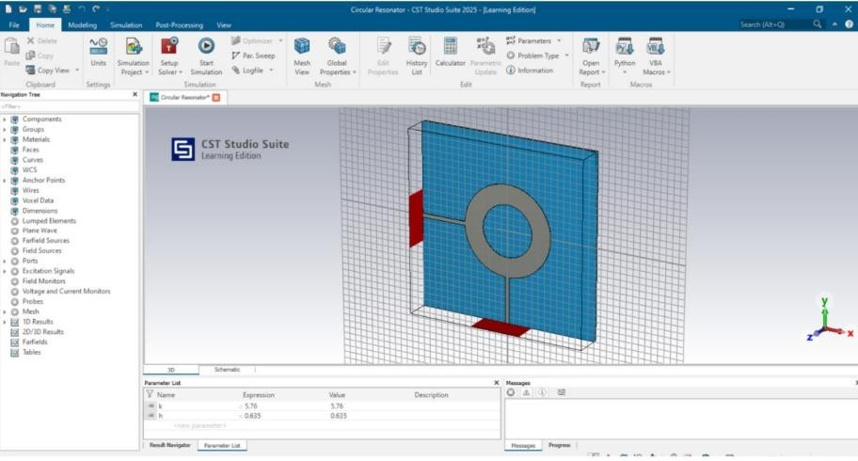
Output:
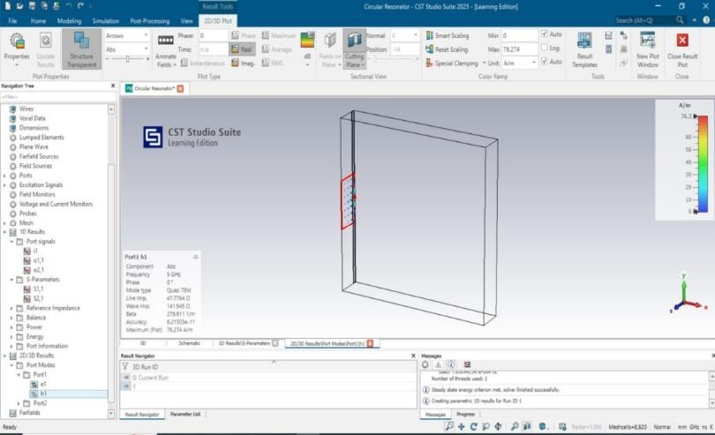
Test Case 2:
Analyze the electric field and magnetic field distribution at Port 2of the circular resonator and examine the electric and magnetic field parameters at Port 2 for studying electromagnetic field behavior and validating the system performance.

Output:
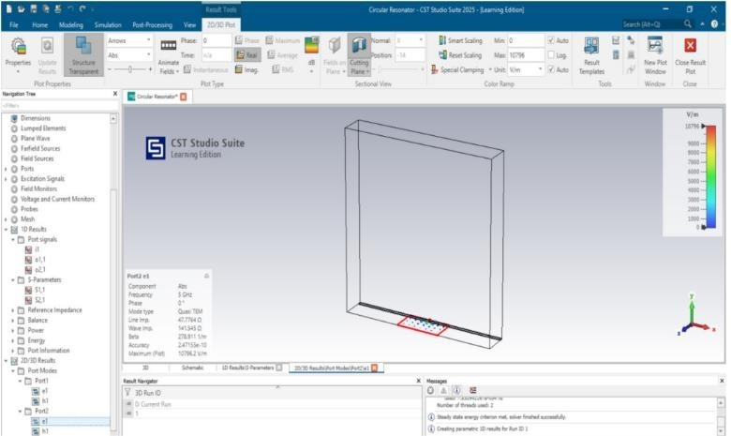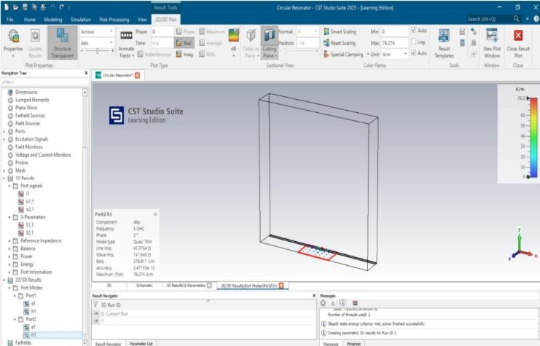
RESULT:
The circular resonator was successfully simulated using CST Studio Suite. The electric field distribution
at Port 1 was observed and analyzed, showing the expected spatial variation and field intensity profile
across the port region. The magnetic field distribution at Port 1 was also obtained, indicating the
corresponding magnetic field patterns consistent with electromagnetic wave propagation. The electric and
magnetic field parameters at Port 1 were successfully measured and recorded.

